Living Blue – Marine Reserves - Vocabulary
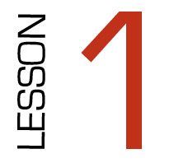

Definitions
Look at the definitions. Create a picture in your mind showing their
Meaning then draw the picutre in the box provided

WORD | CREATE IMAGE | MEANING
Biodiversity |  | The different types of life in a community. The greater the numbers and types of different species the greater the biodiversity.
Habitats |  | The place where a plant or animal lives
Kiatiakitanga |  | Guardianship and protection of the environment (for long term benefit of everyone and future generations)
Protected |  | To keep safe
Endangered |  | At risk of becoming extinct
Sustainable |  | Can go on and on for ever
Species |  | What type is it
Ecosystem |  | Animals and plants that live together and are dependent on each other
Reserve |  | To protect something for future use
Co-governance |  | To share decision making

