Living Blue – Marine Reserves
‘Why do we need Marine Reserves?’

Comprehension Questions
Why do we need no-take marine sanctuaries?
1. Marine sanctuaries will help parts of The Bay of Islands return to what state?
2. What happens when we take too many of the top predators e.g. snapper and crayfish?
3. What is a kina barren?
4. How do kina make the seabed barren and bare?

5. Why is it important to have healthy kelp (seaweed)?

6. Look at the image below. What is the difference between the fishing area and the no-fishing area?

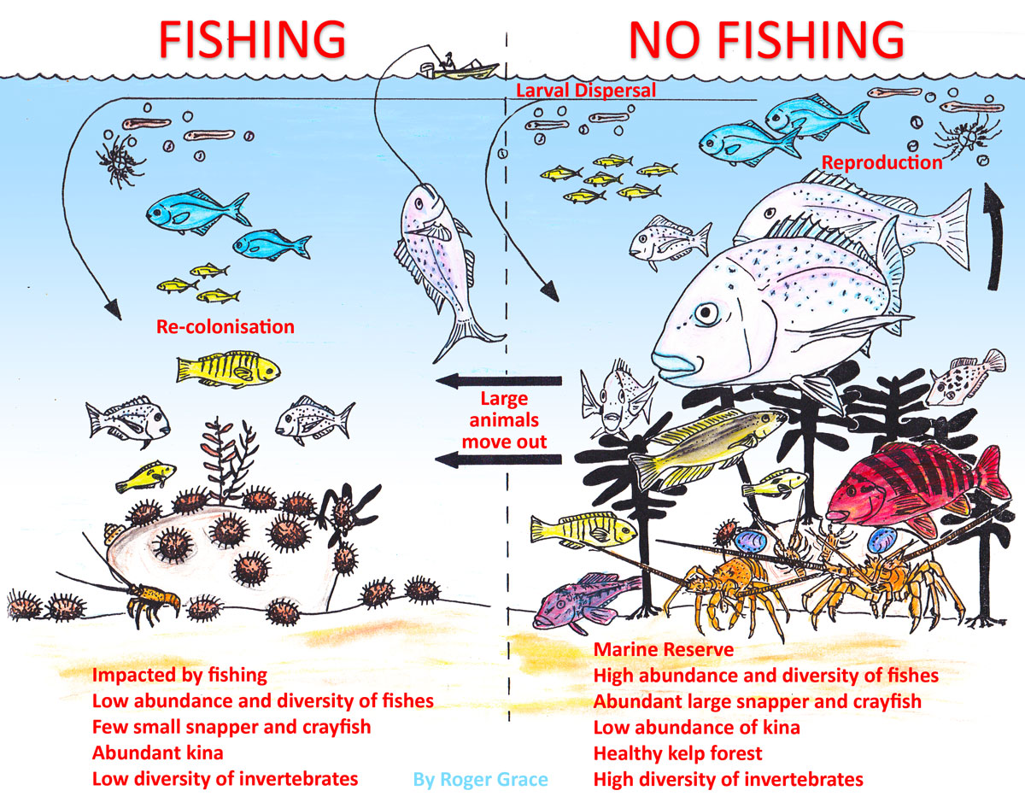

What do you think happens to the fishing area if it has a no-take (no fishing), protected area nearby?

Teachers Answers

1. Marine sanctuaries will help parts of The Bay of Islands return to what state?
A natural state

2. What happens when we take too many of the top predators e.g. snapper and crayfish?
Balance is upset, fish numbers fall

3. What is a kina barren?

Bare rock and lots of sea urchins, no kelp or fish nursery

4. How do kina make the seabed barren and bare?
Eat through kelp (seaweed)

5. Why is it important to have healthy kelp (seaweed)?

To encourage marine biodiversity

6. Look at the image below. What is the difference between the fishing area and the no-fishing area?

No kina barren, more fish, larger fish, greater biodiversity, returned natural state.

What do you think happens to the fishing area if it has a no-take (no fishing), protected area nearby?

Any reasonable answer.

