Living Blue: Marine Reserves
The Something Game
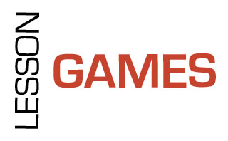

You have 20 minutes to draw a sketch map of a marine environment – you must include as many things as you can that fit the following descriptions.

Something that is:

- Fragile
- Old
- Prickly
- Dependent on something else
- Not natural
- Dead
- A home
- Foreign
- Food
- Protected
- Wet
- Alive
- Colourful
- Breakable
- Unusual
- Exotic
- Unnecessary
- Miniature
- Smelly
- Squashed
- Living on dead things
- Hungry

